Detecting Phishing website using data mining techniques
Dhruv Mehta (1643357)

- Description of dataset:
Phishing website dataset is taken from UCI machine learning repository. The dataset was collected by analyzing a collection of 2456 websites among which some were used for phishing and others not. For each website included in the dataset, 30 attributes are given. These features are defined by W3C. Some of the features are written below. Each website features in the dataset is labeled by -1 if it is not a phishing website and by 1 if it is a website used for phishing and 0 if suspicious.
Phishing website features-
1) Using IP address-
If an IP address is used as an alternative of the domain name in the URL, such as “http://125.98.3.123/fake.html”, users can be sure that someone is trying to steal their personal information. Sometimes, the IP address is even transformed into hexadecimal code as shown in the following link “http://0x58.0xCC.0xCA.0x62/2/paypal.ca/index.html”.
Rule: IF$\left\{\begin{aligned}If The Domain Part has an IP Address → Phishing \\ Otherwise→ Legitimate\end{aligned}\right.$

2) Long URL to hide the suspicious part-
Phishers can use long URL to hide the doubtful part in the address bar. For example:
http://federmacedoadv.com.br/3f/aze/ab51e2e319e51502f416dbe46b773a5e/?cmd=_home&amp;dispatch=11004d58f5b74f8dc1e7c2e8dd4105e811004d58f5b74f8dc1e7c2e8dd4105e8@phishing.website.html
To ensure accuracy of our study, we calculated the length of URLs in the dataset and produced an average URL length. The results showed that if the length of the URL is greater than or equal 54 characters then the URL classified as phishing. By reviewing our dataset we were able to find 1220 URLs lengths equals to 54 or more which constitute 48.8% of the total dataset size.

Rule: IF$\left\{\begin{aligned}URL length<54 → feature=Legitimate \\ else if URL length≥54 and ≤75 → feature=Suspicious \\ otherwise→ feature=Phishing\end{aligned}\right.$

We have been able to update this feature rule by using a method based on frequency and thus improving upon its accuracy.
3) Using URL shortening services “Tiny URL”
URL shortening is a method on the “World Wide Web” in which a URL may be made considerably smaller in length and still lead to the required webpage. This is accomplished by means of an “HTTP Redirect” on a domain name that is short, which links to the webpage that has a long URL. For example, the URL “http://portal.hud.ac.uk/” can be shortened to “bit.ly/19DXSk4”.
Rule: IF$\left\{\begin{aligned}TinyURL → Phishing \\ Otherwise→ Legitimate\end{aligned}\right.$

4) URLs having “@” symbol
Using “@” symbol in the URL leads the browser to ignore everything preceding the “@” symbol and the real address often follows the “@” symbol.
Rule: IF $\left\{\begin{aligned}Url Having @ Symbol→ Phishing \\ Otherwise→ Legitimate\end{aligned}\right.$

5) HTTPS (Hyper Text Transfer Protocol with Secure Sockets Layer)
The existence of HTTPS is very important in giving the impression of website legitimacy, but this is clearly not enough. The authors in suggest checking the certificate assigned with HTTPS including the extent of the trust certificate issuer, and the certificate age. Certificate Authorities that are consistently listed among the top trustworthy names include: “GeoTrust, GoDaddy, Network Solutions, Thawte, Comodo, Doster and VeriSign”. Furthermore, by testing out our datasets, we find that the minimum age of a reputable certificate is two years.
Rule: IF$\left\{\begin{aligned}Use https and Issuer Is Trusted &and Age of Certificate≥ 1 Years → Legitimate \\ Using https and Issuer Is Not Trusted → Suspicious \\ Otherwise→ Phishing\end{aligned}\right.$

6) The existence of “HTTPS” token in the Domain part of the URL
The phishers may add the “HTTPS” token to the domain part of a URL in order to trick users. For example,
http://https-www-paypal-it-webapps-mpp-home.soft-hair.com/.
Rule: IF$\left\{\begin{aligned}\text{Using }HTTP Token in Domain Part of The URL→ Phishing \\ Otherwise→ Legitimate\end{aligned}\right.$

We are going to use following algorithms to classify the websites.
1) Decision tree algorithm
2) Naïve Bayesian Algorithm

1) Decision tree algorithm-
Decision trees are a powerful prediction method used to predict based on the training dataset. The representation of the CART model is a binary tree. A node represents a single input variable (X) and a split point on that variable, assuming the variable is numeric. The leaf nodes (also called terminal nodes) of the tree contain an output variable (y) which is used to make a prediction.

Once created, a tree can be navigated with a new row of data following each branch with the splits until a final prediction is made. Creating a binary decision tree is actually a process of dividing up the input space. A greedy approach is used to divide the space called recursive binary splitting. This is a numerical procedure where all the values are lined up and different split points are tried and tested using a cost function. The split with the best cost is selected. All input variables and all possible split points are evaluated and chosen in a greedy manner based on the cost function.

The Gini index is the name of the cost function used to evaluate splits in the dataset. A split in the dataset involves one input attribute and one value for that attribute. It can be used to divide training patterns into two groups of rows. Once the best split is found, we can use it as a node in our decision tree. We need to decide when to stop growing a tree. We can do that using the depth and the number of rows that the node is responsible for in the training dataset.

Maximum Tree Depth-This is the maximum number of nodes from the root node of the tree.
Once a maximum depth of the tree is met, we must stop splitting adding new nodes.

Minimum Node Records- This is the minimum number of training patterns that a given node is responsible for. Once at or below this minimum, we must stop splitting and adding new nodes.

Making predictions with a decision tree involves navigating the tree with the specifically provided row of data. The last node of the tree is known as terminal node, and it is responsible for the prediction.

Classification metrics which are considered to evaluate a classifier are:

- Accuracy - Accuracy rate is the percentage of test set samples that are correctly classified by the model.
- Precision – exactness- what % of tuples that the classifier labeled as positive are actually positive.
- Recall - completeness – what % of positive tuples did the classifier label as positive.
- F-score - harmonic mean of precision and recall.

2) Naïve Bayesian Algorithm-

Naïve Bayesian is based on Bayes theorem. It is a statistical classifier that performs probabilistic predictions. A simple Bayesian classifier, Naïve Bayesian classifier, has comparable performance with decision tree. Given a training data X, posterior probability of a hypothesis H, P(H|X), follows the Bayes theorem

Informally, it can be written as posterior x prior/evidence. A simplified assumption is made that attributes are conditionally independent. It is given by,

It is easy to implement and also good results are obtained in most of the cases. Its disadvantage is that there is class conditional independence because of which there is loss of accuracy.

- Purpose:

Phishing attack is used to steal confidential information of a user. Fraud websites appears like genuine websites with the logo and graphics of genuine website. This project aims to detect fraud or phishing website using data mining techniques. W3C standard defines characteristics which can be used to distinguish a legal and fraud website. These characteristics can be used for classification. By using data mining techniques, we will generate a classification model which is used to manage and model data. This helps to make a prediction whether the website is legal or fraud.

- Expected outcomes and result:

We will use a data mining techniques that will generate a classification model from a training dataset and then this model will be applied to testing dataset which will label the websites as malicious or legitimate. We will compare the accuracy of two models generated and conclude which is better among those two.

- Intermediate steps of project:

1) Collect dataset containing malicious and legitimate websites.
2) Writing code to divide the dataset into training and testing sets and code for displaying the evaluation results.
3) Run both the classification algorithms on the dataset.
4) Compare the results for the two models generated using two algorithms and specify which is better.
- Responsibilities:

1) Sayali Sane – Working on the dataset analysis. Finding information about the features used. Finding the commands for classification metrics.
2) Dhruv Mehta- Research about algorithms, datasets can be used for features extraction, functionality and applying decision tree algorithm and its working in project.
3) Snehal Sawant- Finding dataset and analyzing it. Writing python code to analyze the dataset. Research about writing python code for comparing two classification algorithms.
4) Sai Bhargav Ram Bikki – Study of Naïve Bayesian Algorithm and its working.

- Code:

- Decision Tree Code-
from sklearn import tree
from sklearn.metrics import accuracy_score
from sklearn.metrics import confusion_matrix
from sklearn.metrics import precision_score
from sklearn.metrics import classification_report

import numpy as np
from sklearn import tree
from sklearn.tree import export_graphviz
import graphviz
import time

def load_data():

#Get the data
training_data = np.genfromtxt(r'C:\Users\OM\Downloads\Dataset.csv', delimiter=',', dtype=np.int32)

inputs = training_data[:,:-1] # Get the inputs - All rows and all columns except the last one
outputs = training_data[:,-1] # Get the labels

# Divide the data set into training and testing. Total=2456
# Training dataset (1500 rows)
# Testing dataset (956 rows)
training_inputs = inputs[:1500] # Select first 1500 rows (0-1499) excluding last column
training_outputs = outputs[:1500] # Select first 1500 rows (0-1499) with only last column
testing_inputs = inputs[1500:] # Select remaining rows (1500-2455) excluding last column
testing_outputs = outputs[1500:] # Select remaining rows (1500-2455) with only last column

# Return the four arrays
return training_inputs, training_outputs, testing_inputs, testing_outputs

if __name__ == '__main__': # Entry point of the program
start_time = time.time()
train_inputs, train_outputs, test_inputs, test_outputs = load_data() # get the data

classifier = tree.DecisionTreeClassifier() # Create a decision tree classifier model using scikit-learn
classifier.fit(train_inputs, train_outputs) # Train the classifier model

predictions = classifier.predict(test_inputs) # make the predictions on testing data

confusionmatrix=confusion_matrix(test_outputs,predictions) # Create a confusion matrix

accuracy = 100.0 * accuracy_score(test_outputs, predictions) # Calculate the accuracy
print ("The accuracy of your decision tree on testing data is: " + str(round(accuracy,2))+ "%"+"\n")
print("confusion matrix=\n",confusionmatrix)

error=(1-accuracy/100.0)*100.0
print("The error rate of the decision tree on testing data is: " + str(round(error,2)) + "%"+"\n")

report=classification_report(test_outputs,predictions)
print("The classification report is:\n "+ str(report))

dot_data = tree.export_graphviz(classifier, out_file=None,
feature_names=["Having_IP_Address","URL_Length","Shortening_service","@","//","Prefix_suffix",
"having Subdomain","SSLfinal_state", "Domain_Registration_length","favicon","port","HTTPS_Token","Request_URL",
"URL_of_Anchor","Links_in_Tags","SFH","Submitiing_to_email","Abnormal_URL","Redirect"," On_mouseover",
"Rightclick","popup","iframe","ageofdomain","DNS","web_traffic","pagerank",
"google_index","links","statistical_report"],class_names=["Legitimate","Malicious"],
filled=True, rounded=True,
special_characters=True)
graph = graphviz.Source(dot_data)
graph.render("map",view=True)
print("Time = %s seconds " % (time.time() - start_time))

- Naïve Bayesian Classifer-

from sklearn.metrics import accuracy_score
from sklearn.metrics import confusion_matrix
from sklearn.metrics import precision_score
from sklearn.metrics import classification_report

import numpy as np
from sklearn.naive_bayes import GaussianNB
import time

def load_data():

#Get the data
training_data = np.genfromtxt(r'C:\Users\OM\Downloads\Dataset.csv', delimiter=',', dtype=np.int32)

inputs = training_data[:,:-1] # Get the inputs - All rows and all columns except the last one

outputs = training_data[:,-1] # Get the labels

# Divide the data set into training and testing. Total=2456
# Training dataset (1500 rows)
# Training dataset (956 rows)
training_inputs = inputs[:1500] # Select first 1500 rows (0-1499) excluding last column
training_outputs = outputs[:1500] # Select first 1500 rows (0-1499) with only last column
testing_inputs = inputs[1500:] # Select remaining rows (1500-2455) excluding last column
testing_outputs = outputs[1500:] # Select remaining rows (1500-2455) with only last column

# Return the four arrays
return training_inputs, training_outputs, testing_inputs, testing_outputs

if __name__ == '__main__': # Entry point of the program
start_time = time.time()
train_inputs, train_outputs, test_inputs, test_outputs = load_data() # get the data

classifier= GaussianNB()

classifier.fit(train_inputs, train_outputs) # Train the classifier model

predictions = classifier.predict(test_inputs) # make the predictions on testing data

confusionmatrix=confusion_matrix(test_outputs,predictions) # Create a confusion matrix

accuracy = 100.0 * accuracy_score(test_outputs, predictions) # Calculate the accuracy
print ("The accuracy of your Naive Bayesian classifier on testing data is: " + str(round(accuracy,2))+ "%")
print("confusion matrix=\n",confusionmatrix)

error=(1-accuracy/100.0)*100.0
print("The error rate of the Naive Bayesian classifier on testing data is: " + str(round(error,2)) + "%")

report=classification_report(test_outputs,predictions)
print("The classification report is:\n "+ str(report))
print("Time = %s seconds " % (time.time() - start_time))

- Evaluation Results:

- Decision Tree Classifier outcome-

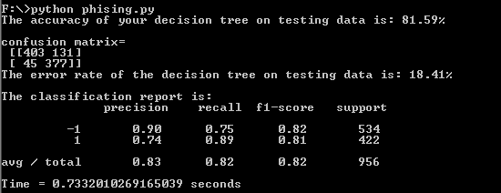

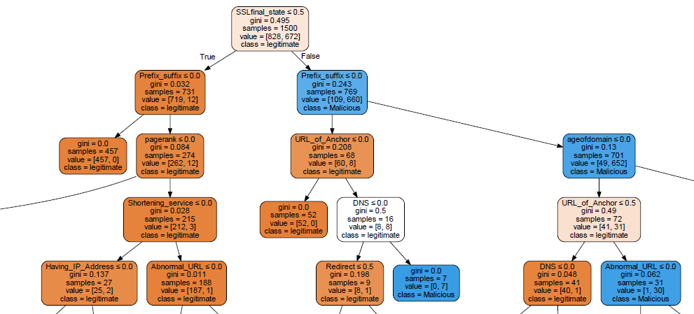

- The decision tree is generated using reduction in impurity (gini) as the attribute selection measure.
- In our case the attribute SSL final_state has higher reduction in impurity. So it is selected as the attribute for splitting.
- Samples represent the total samples at a split point.
- Values denote the number which belong to the two classes that is Legitimate and Malicious.

- Naïve Bayesian Classifier outcome-

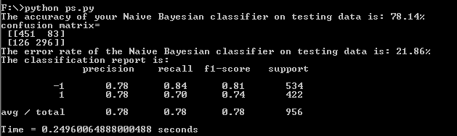

- Conclusion:

- Both classifiers were compared on the basis of the accuracy and error rate.
- On comparison we find that Decision Tree classifier model is more accurate as compared to Naïve Bayesian Classifier model.
- The time required for execution for both algorithms was displayed.
- It shows that Naive Bayesian is faster as compared to Decision tree Algorithm.

- References:

[1] S. Thakur, E. Meenakshi, and A. Priya, "Detection of malicious URLs in big data using RIPPER algorithm," in Recent Trends in Electronics, Information & Communication Technology (RTEICT), 2017 2nd IEEE International Conference on, 2017, pp. 1296-1301: IEEE.
[2] U. Prajapati, N. Sangal, and D. Patole, "Fraud Website Detection using Data Mining," International Journal of Computer Applications, vol. 141, no. 3, 2016.
[3] R. K. Kumar, G. Poonkuzhali, and P. Sudhakar, "Comparative study on email spam classifier using data mining techniques," in Proceedings of the International MultiConference of Engineers and Computer Scientists, 2012, vol. 1, pp. 14-16.
[4] D. Sahoo, C. Liu, and S. C. Hoi, "Malicious URL detection using machine learning: A survey," arXiv preprint arXiv:1701.07179, 2017.
[5] D. Hassan, "On determining the most effective subset of features for detecting phishing websites," International Journal of Computer Applications (0975-8887), vol. 122, no. 20, 2015.

- Future Work:

We can create a User Interface to allow user to enter a website URL so that they can know whether the website is malicious or legitimate.

